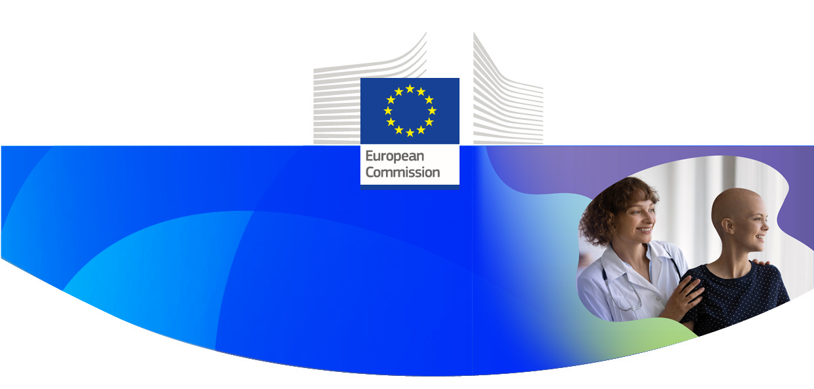
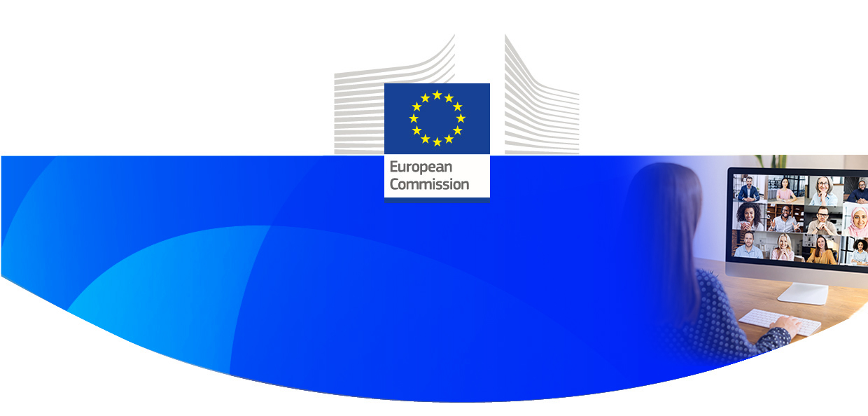
c
#

#EUHPP Live Webinar
EU Cancer Mission
Project cluster policy webinar
Cancer Prevention
(Early Detection and Screening)
10 DECEMBER 2024, 14.00 – 17.00 CET , BRUSSELS TIME


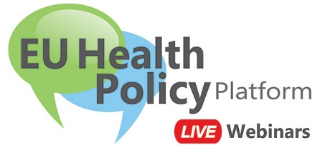




Dear colleague,

We invite you to join the second EU Cancer Mission project cluster policy webinar, exploring how to work together to make better use of research project results in the area of cancer prevention (early detection and screening).

This #EUHPP Live Webinar will bring together stakeholder and citizen perspectives on research and innovation providing an early exposure to the cluster projects launched under the EU Cancer Mission.

Register to this webinar following this link.
Once registered, you will receive the calendar invitation from Webex. Please pin it in your calendar and go back to it on the webinar day. This webinar will be held in English.

If you have any further questions, please contact sante-hpp@ec.europa.eu

We are looking forward to welcoming you online.

The EU Health Policy Platform team
European Commission
Directorate-General for Health and Food Safety
Unit B3 – Health monitoring and cooperation, Health networks
Luxembourg

#HealthUnion


The EU Health Policy Platform will host a live webinar, following this agenda:

14.00 – 14.05 | Welcome  Chair: Petra Goyens, Deputy Head of Unit, Combatting Diseases Unit, DG Research & Innovation, European Commission
14.05 – 14.15 | Opening remarks  Joanna Drake, Deputy Director-General, DG Research & Innovation and Mission Manager of the EU Cancer Mission, European Commission  Philippe Roux, Head of Unit, Cancer, Health in all Policies,  Directorate B, DG Health and Food Safety, European Commission
14.15 – 14.40 | Introduction to Cancer Screening (background/context)  Keynote: Professor Harry de Koning, Professor of Public Health and Screening Evaluation, Erasmus University, Rotterdam – short overview of the state of play of Cancer screening.  EU Cancer screening recommendations – Domenico Fiorenza Glanzmann, Policy Officer, Cancer, Health in all Policies, Directorate B, DG Health and Food Safety, European Commission  Screening Cluster video
14.40 – 15.40 | Panel Session 1: Innovation in Cancer Screening – new technologies  Moderator: Cancer Mission Board  Panel Members:  - Klaus Pantel - PANCAID  - Eric Lucas - CanScreen-ECIS  - Ioannis Papanikolaou - DIOPTRA  - Pippa Powell - SOLACE  - Tamara Hussong Milagre, EVITA Cancer Charity – (partner in MammoScreen)  - Anaxagoras Fotopoulos – ONCOSCREEN  Slido questions/audience questions

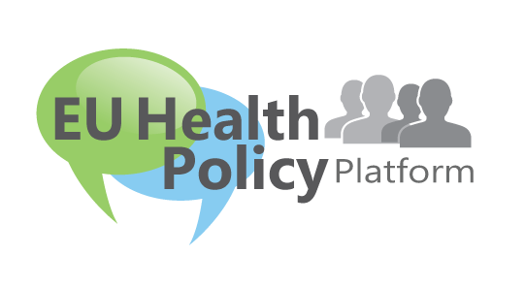

15.40 – 15.50 | Coffee break
15.50 – 16.50 | Panel Session 2: Early Cancer Detection  Moderator: Dr Eleni Tolma, Member of the Cancer Mission Board  Panel Members:  - Paolo Giorgi Rossi, H2020 project, MyPeBS  - Hendrik Van Poppel - PRAISE-U  - Yuval Ebenstein - SANGUINE  - EMODA, Health Software Development Services, (LUCIA project)  - Mária Rečková, Improving Cancer Care Coordination and Screening in Latvia and Slovakia (ICCCS) project  - Anna Wurm - EIT Health  Slido questions/audience questions
16.50 – 17.00 | Closing remarks  Jan van de Loo, Senior Expert, Cancer Mission Secretariat, DG RTD

Please be informed that this #EUHPP Live Webinar will be recorded. We invite you to consult the live webinar privacy statement below.

Register now to the EU Health Policy Platform to promote your initiatives, join upcoming webinars and stay tuned on the latest news.

By registering and participating in this webinar, you accept the #EUHPP Live Webinars privacy statement

All the information you need on Public Health Website
Follow us on X @EU_Health and join the conversation on #EUHPP

